

Assignment # 2

SUBMITTED TO: Ms. Qurat-ul-Ain

SUBMITTED BY: Muhammad Moiz Ansari

Roll No: 23i-0523

SECTION: BS(CS)-23 F

Contents
Executive Summary: 3
Introduction: 3
Background: 3
Ongoing Research: 5
Theories of Learning: 5
• Motivation: 5
• Self-Determination: 5
• Achievement Goal: 5
• Social Learning: 5
Benefits: 5
Applications: 6
• Minecraft: 6
Future implications: 7
Conclusion: 7
References: 8

Executive Summary:
Gamification in education basically makes educators apply game design elements to an educational setting. The goal is to make learning more interactive. It’s about breaking the concept of a “game” down into constituent game design elements. It is tricky considering how vast the differences are among, like chess, The Sims, tag, tic-tac-toe, etc. There is in fact a range of elements that games might have, with different players being attracted to different elements. When educators adopt features like the ones listed into a lesson, even if the result isn’t much a game, the person learns the lesson.

Introduction:
Gamification in education refers to the introduction of game design elements and gameful experiences in the design of learning processes. It has been adopted to support learning in a variety of contexts and subject areas and to address related attitudes, activities, and behaviors, such as participatory approaches, collaboration, self-guided study, completion of assignments, making assessments easier and more effective, integration of exploratory approaches to learning, and strengthening student creativity.

Background:
According to Wikipedia, a study at MIT Sloan found that ideation in games helped the participants generate more creative and better ideas than compared to simple interface without any gamification or interactivity involved.
The first-time gamification was recognized was in 1908, when The Boy Scout Movement was founded. The Boys Scout awarded badges for different achievements and scouts could also earn badges by performing well in their activities, following the rules and regulations, and attending special events, etc.
This desire to involve gamification in such activities draws along the concept from educational psychology and behavioral science. It is based on the idea that students are more interested and motivated in such educational environments that are based on games and competition.
In 1982, the Academics recognized the importance of gaming in education and research started to appear around what could be learned from computer games in an educational environment.
In 1985, Emergence of Children’s Software Industry took place. In this era, games involving Mathematics, typewriting, physics, were introduced in which the whole educational stuff was merged into the games. Like different stages and levels featured quizzes, assignments in the shape of missions which caught student’s interest. Some of the examples are Math Blaster, Mavis Beacon Teaches Typing, etc.
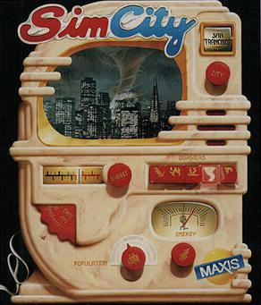
In the late 80’s, the growing sophistication of educational games took place. Developers came up with an idea of such amazing games which increased the vastness of education obtained through games. Like, SimCity arrived in 1889, which developed creativity among the people who played it of how to run a city.
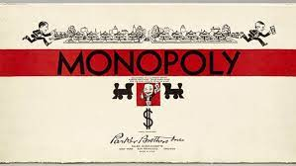
In the 90’s, handhelds, videogame consoles and mobiles took place which provided a better and more interactive user interface which allowed children to learn new things easily.
In 1935, Monopoly was released which provided a platform to learn to calculate money, and terms like rent, loan, profit, loss, bankruptcy, etc.
1n 1995, 3D virtual learning platform was introduced. Virtual worlds with any types of content became popular. It provided interactive user interface to allow people to learn virtually by feeling being in a place where they can’t be like Cockpits.
In 1996, game players were categorized based on their approach. There are multiple ways to approach different tactics in a game and on that basis the player’s personality types and other characteristics were identified.
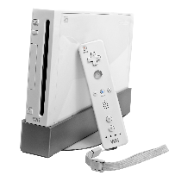
In 2002, Gamification is born. Various machines like Vending Machines and ATM machines started using interface same as that used in games.
In 2006, Wii game was released. It uses a motion detector remote which can be used to play games physically using the remote. It helped people learn games effectively.
In 2010, gamification informs course design and curriculum development. Developing games was included as a part of the course in programming, which is still very useful nowadays.
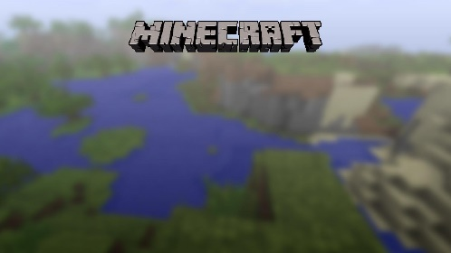
In 2011, Minecraft was released which proved to be a huge success in developing creativity in people of all ages. It allows the user to build a variety of constructions using blocks. It also helps to learn new real-life things in nature.

Ongoing Research:

Theories of Learning:
The major theories of learning when considering gamifying education can be broken into four categories. Motivation, Self-determination, Achievement Goal, and Social Learning.

Motivation:
Gamified interfaces give motivation to students. Like, in an educational app, if a student solves a Hard Difficulty problem, he gets a title of being the smartest of all. So, this will definitely provide motivation to students to get the title.

Self-Determination:
Gamified methods provide self-determination. Just like a person struggles to complete a task or a stage in any game and tries his best in it. Similarly, one will struggle in their education too.

Achievement Goal:
Nothing can be achieved without goal. So, with the help of achievement goals, the user will always try to attain their goals to get their achievement badges.

Social Learning:
Students can learn to educate themselves socially by studying though online platforms like YouTube, zoom, google meet, etc.

Benefits:
- Gamification provides the students with their ownership of learning. Since they can learn games easily, they learn faster.
- It provides the freedom to fail again and again and try again because any person doesn’t hesitate to try again in a game and always struggle to achieve the goal.
- It provides chances to increase fun and joy in the classroom.
- It helps to take learning visible as according to several studies, students tend to react to visual information faster than they respond to plain text. Beyond that, visual materials can also help improve learning on many levels.

Applications:

Minecraft:
Minecraft is a gamification tool which allows students to create, participate and take part in project-based activities. Minecraft can be used by teachers to access curricular activities while promoting motivation and engagement. Minecraft is a construction-based survival game that allows players to move around and build different types of structures with blocks in the virtual world. It allows user to craft different tools and objects and survive the world with imaginary creatures.
Some of the concepts used in Minecraft are according to the real world so the user gets to learn things about the real world in a virtual game. So, this provides a really good platform for learning.
In January 2016, Microsoft announced the expansion of Minecraft into a tool for education called Minecraft: Education Edition or Minecraft EDU. The idea behind Minecraft EDU is the same as the original, with a few modifications made to make it more usable and flexible for educators. Additional tools are available to assist cooperation and structured learning, such as the possibility to download worlds from their website that directly align with curricular standards. The ability to encourage creativity is frequently a factor in the decision to bring Minecraft into the classroom. Concerns about the importance of creativity in STEM (science, technology, engineering, and mathematics) education were brought up, according to Nguyen. For fulfilling curriculum expectations and creative growth, Minecraft became the solution. Numerous studies illustrate a range of advantageous effects of play-based learning using toys .Nguyen's investigation on the significance that building blocks had in the growth of STEM subjects led him to investigate Minecraft and its virtual bricks.

Future implications:
The success of Minecraft in gamifying education suggests an optimistic future for new and exciting educational tools. As the research continues, the development of new educational games and platforms may occur using the concept as interesting and attractive as in Minecraft.
The study might make it possible to create individualized learning environments. The ability to personalize and adjust learning using Minecraft-based experiences may be available to educators one day.
As Minecraft and similar games like that become more common in education, there will be more focus on digital education which is more effective and interesting to students.
As the research continues, the students’ motivation and interest might be taken into deepen insights and gamified education may be given more focus to implement new ideas for it.

Conclusion:
In conclusion, gamification is an innovative and dynamic approach which is promising revolutionary change in the future world as technology is getting advanced day by day so it will give more chances to create more platforms for education which is easy to use.
Gamification is the use of game elements in learning environment to boost student’s motivation and interest. Teachers incorporate gaming elements into lessons on a regular basis, and the digital era has enhanced the technological resources at their disposal for doing so.
In conclusion, gamification technology now works with mobile devices that offer simple learning elements. However, security or safety design should be one of the top priorities factors that developers should consider.

References:
- https://educationaltechnologyjournal.springeropen.com/articles/10.1186/s41239-017-0042-5#:~:text=Gamification%20in%20education%20refers%20to,the%20design%20of%20learning%20processes.
- https://www.scirp.org/journal/paperinformation.aspx?paperid=121231#:~:text=The%20gamification%20of%20learning%20has,task%2C%20motivation%20and%20learning%20outcomes.
- https://www.hmhco.com/blog/what-is-gamification-in-education#:~:text=Gamification%20in%20education%20means%20that,%2C%20The%20Sims%2C%20and%20tag.
- https://subscription.packtpub.com/book/web-development/9781782168119/1/ch01lvl1sec09/history-of-gamification-in-education#:~:text=Some%20of%20the%20earliest%20uses,Software%20published%20it%20in%201985.
- https://www.teachthought.com/education/a-brief-history-of-gamification-in-education/
- https://en.wikipedia.org/wiki/Gamification_of_learning
- https://www.researchgate.net/profile/Violet-Murwa-2/publication/287480678_The_role_of_gamification_in_education_-_a_literature_review/links/5a9d06420f7e9be379686518/The-role-of-gamification-in-education-a-literature-review.pdf
- https://pressbooks.pub/techandcurriculum/chapter/minecraft/#:~:text=Minecraft%20is%20a%20gamification%20tool,Kuhn%20%26%20Stevens%2C%202017).
- https://www.tandfonline.com/doi/full/10.1080/09523987.2016.1254877?casa_token=qBXc5gzZCzwAAAAA%3AJ5TevoVM5o5Br4pdYvnc6pYUuspOEKAnOb7seg5_37OBd4FOJy4z8tu55XpqyQEwBDxyFho9ivNmO34w
- https://edtechbooks.org/studentguide/gamification#:~:text=Conclusion,are%20available%20to%20do%20so.

